Script Execution by calling bash: Echo
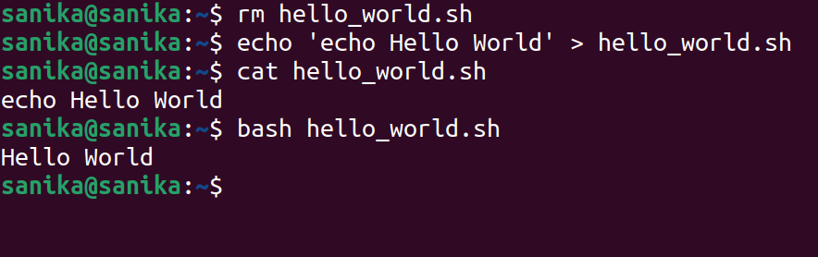
Multiline File Creation
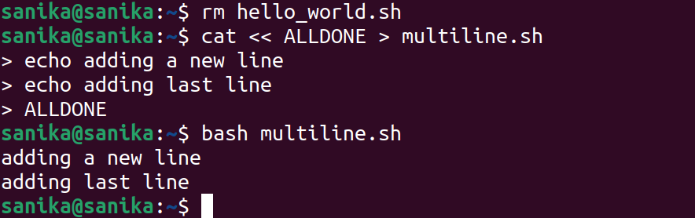
Script Execution with shebang
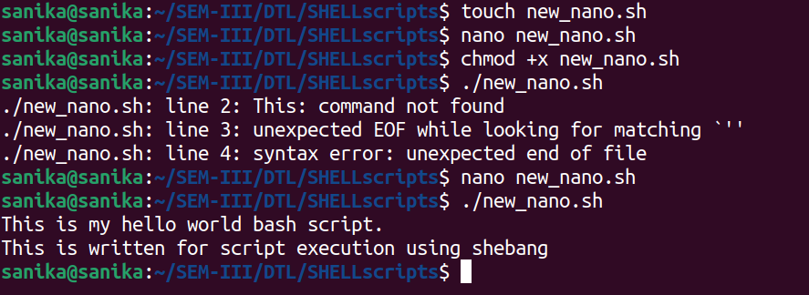

Debugging
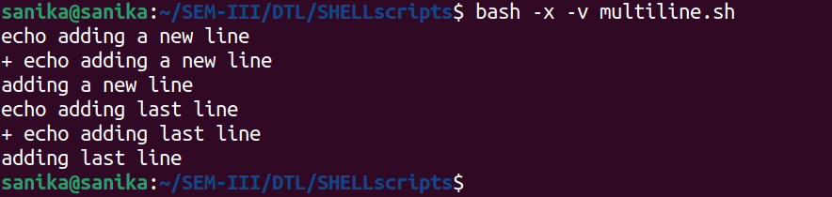
Special Parameters
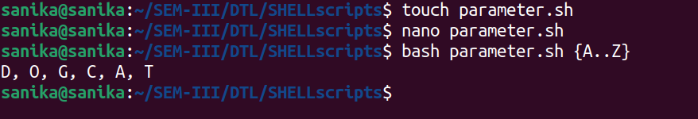
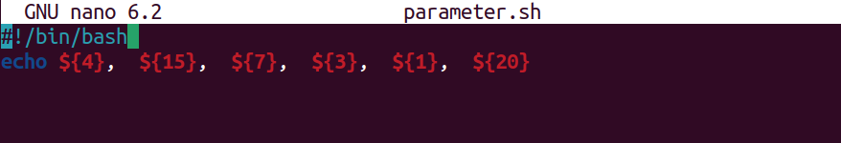
script to explore all special shell parameters

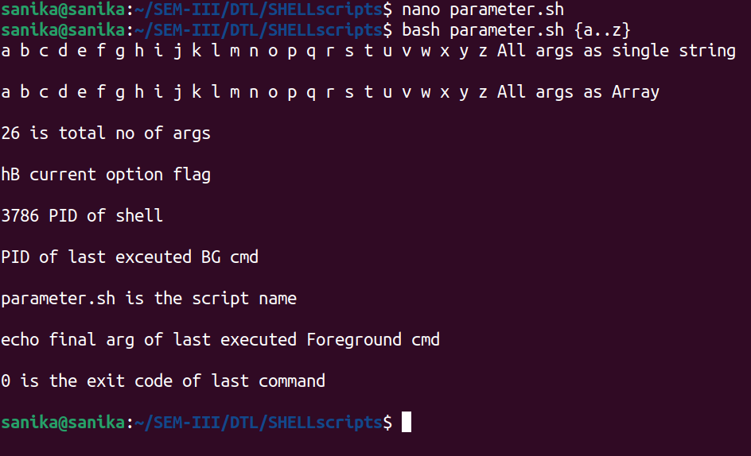

Shell Expansion
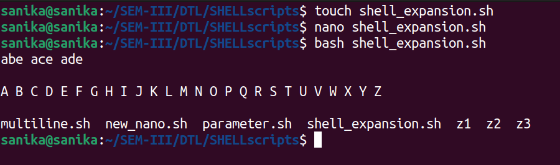
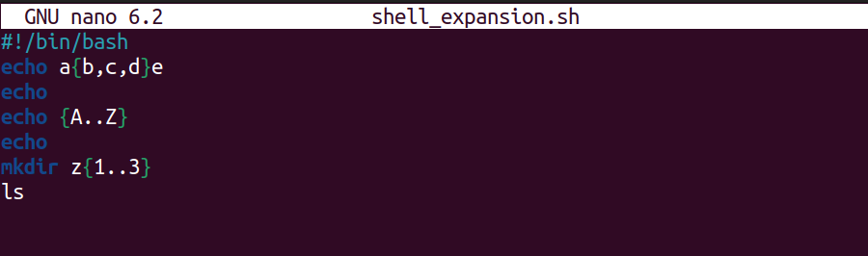

Arithmetic Expansion
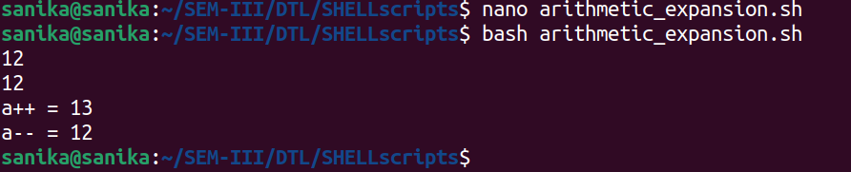
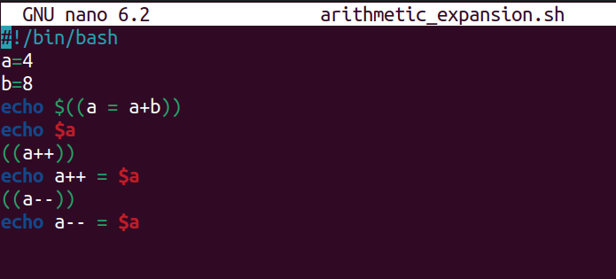

Command Substitution
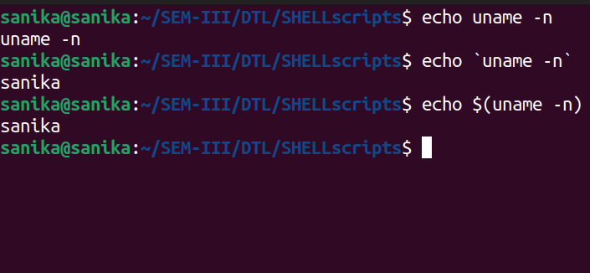

file type
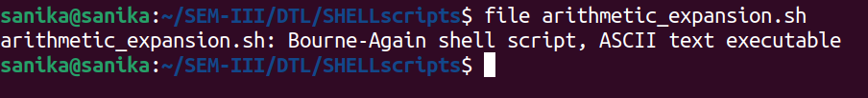
Variables
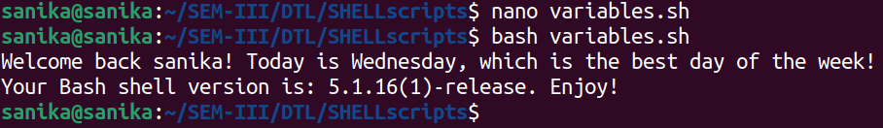
Variables can be created in command line

Backup any user’s home directory
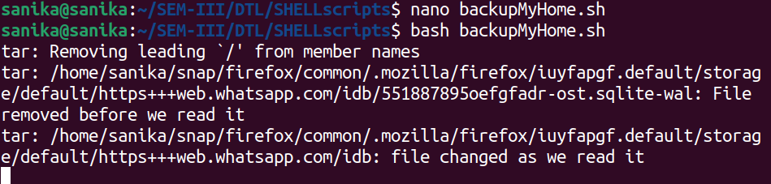
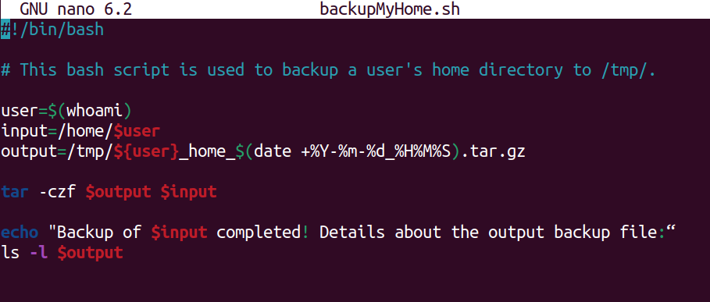

environment variables

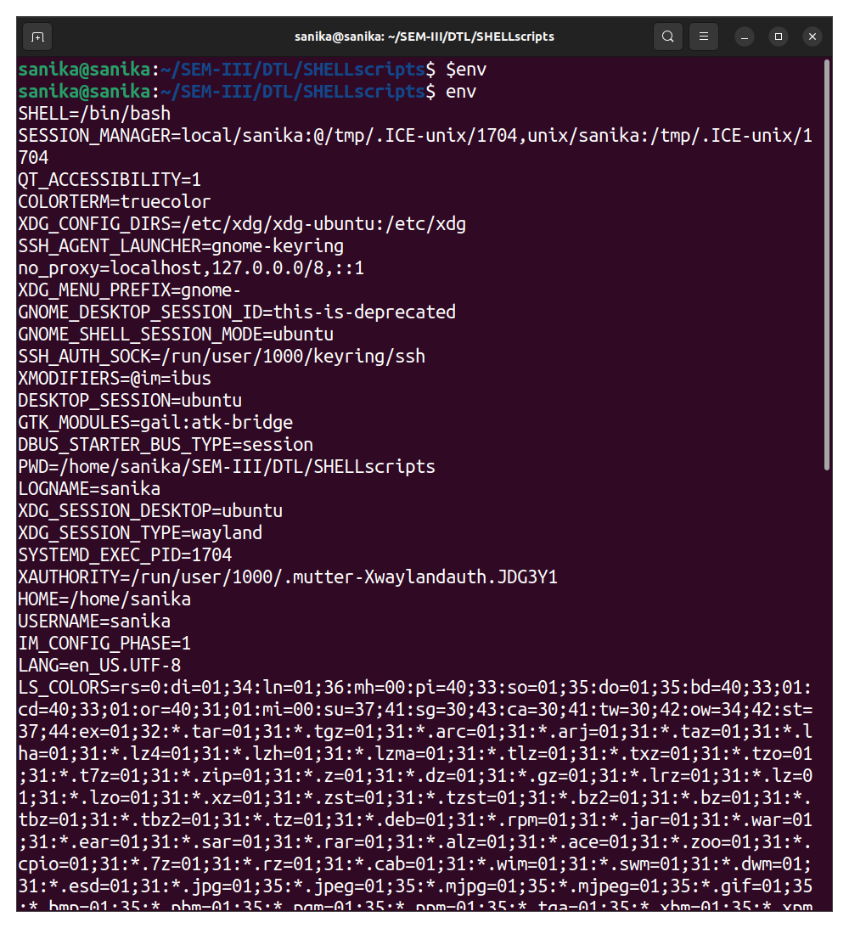

Array
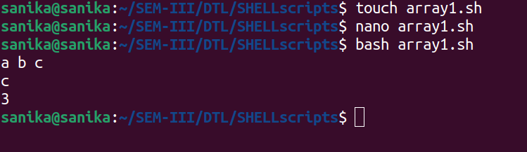
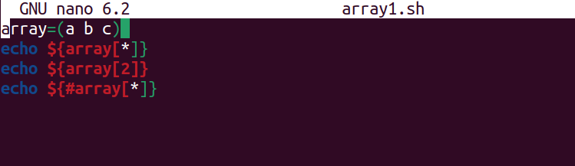

Array using looping:
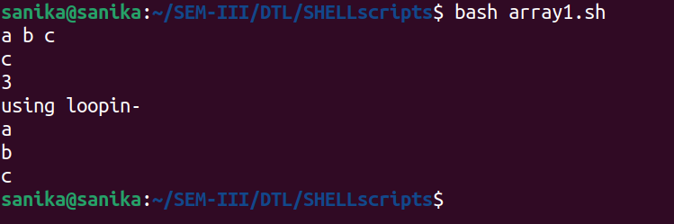
Backup using stderr

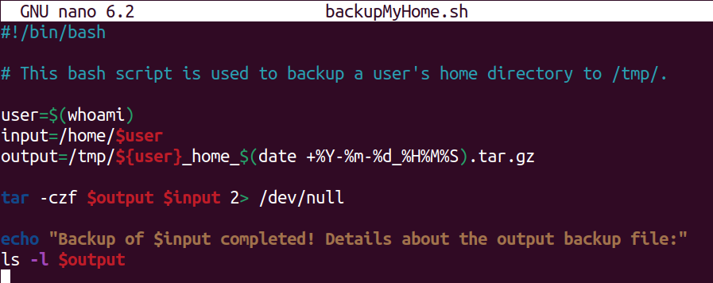

Redirecting stdin
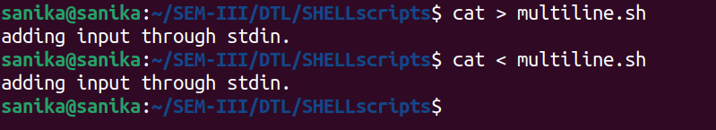

function
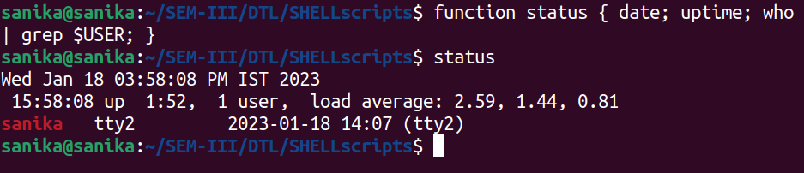

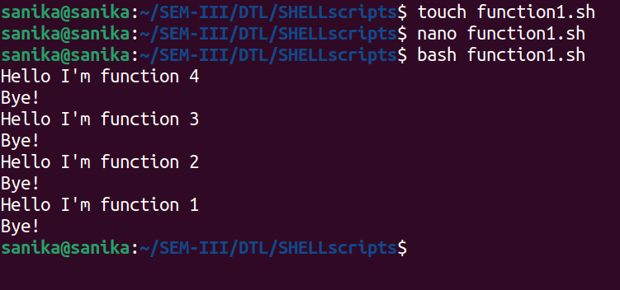

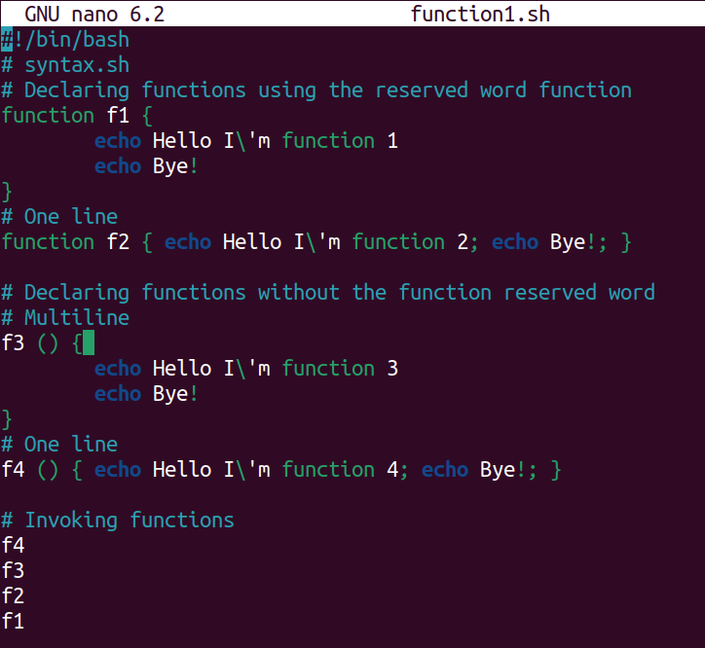
backup using stderr

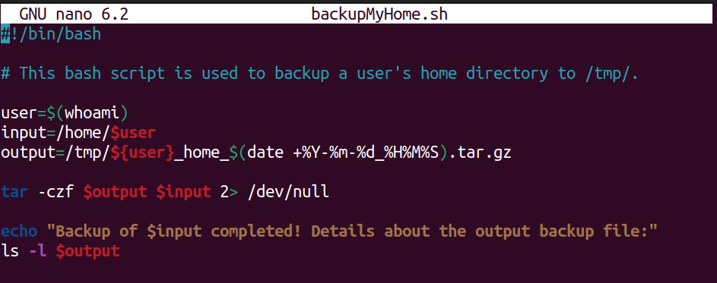

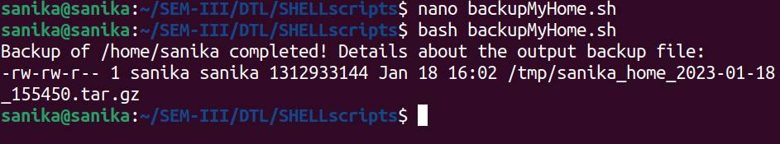

Numeric Comparison
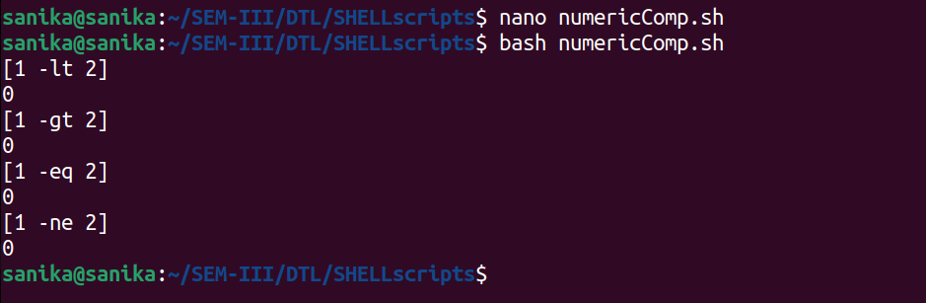
String Comparison
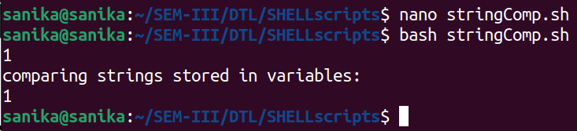

comparision

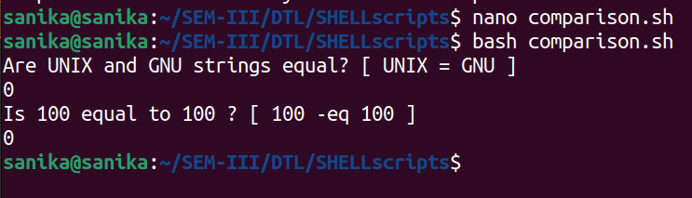

Conditional for arithmetic expressions
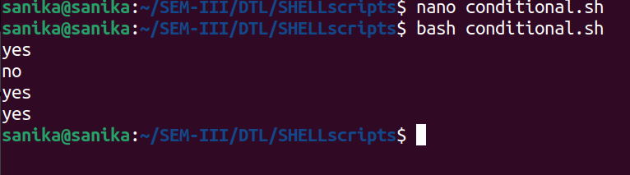
LET

